Moss Hall Schools Federation Governing Board 2021 – 2022 Year Summary

This document is a summary of the work which the Governing Board has carried out this year.
Governing Board Membership
 |  | First Appointed | Term Start | Term End
 | Executive Headteacher
 | Ms Laura Wynne | 06 Jan 2020
 | Parent governors
 | Lis Maimaris | 11 Feb 2020 | 11 Feb 2020 | 10 Feb 2024
 | Adrian Sieff | 11 Feb 2020 | 11 Feb 2020 | 10 Feb 2024
 | Co-opted governors
 | Kirit Amin | 12 Dec 2021 | 12 Dec 2021 | 11 Dec 2025
 | Mo Choonara | 08 Jul 2021 | 08 Jul 2021 | 07 Jul 2025
 | Mr David Dunn | 07 Dec 2020 | 07 Dec 2020 | 06 Dec 2024
 | Mrs Chloe Khan | 04 May 2019 | 04 May 2019 | 03 May 2023
 | Mrs Andrea Muhammad | 22 May 2019 | 22 May 2019 | 21 May 2023
 | Joel Phillips | 05 Dec 2016 | 07 Dec 2020 | 06 Dec 2024
 | Andrea Pieri-Gonzalez | 14 Sep 2021 | 14 Sep 2021 | 13 Sep 2025
 | Patrick Richmond | 24 Jan 2015 | 23 Jan 2019 | 22 Jan 2023
 | Dr Victoria Whitford | 13 Nov 2015 | 13 Nov 2019 | 12 Nov 2023
 | Vacancy (1)
 | Local Authority Governors
 | Mrs Holly Kal-Weiss | 12 Dec 2018 | 12 Dec 2018 | 11 Dec 2022
 | Staff governors
 | Vacancy (1)
Members who left during the year:
- Matt Berger

Governing Board Vacancies
We currently have one co-opted governor vacancy, and one staff governor vacancy. Two governors have ended their terms this academic year and we have co-opted two new governors for this year and are looking to recruit one more through Inspiring Governance. Each year we review our board make-up, looking at our skills audit to fill gaps and recruiting as best we can to reflect the diversity of our community.
Meetings
The Governing Board has met regularly over the year at our two termly committee meetings and once termly full governing board meeting. Ms Wynne has also met fortnightly with the Chair of Governors to discuss rolling items such as safeguarding, attendance, Health and Safety as well as any matters arising. Our two committees are Curriculum, Pupils and Achievement (CPA) where we focus primarily on pupil progress, welfare and the curriculum, and Premises, Finance and Resources (PFR) where we scrutinise the schools’ budgets and support financial decisions. We also met in November and March for visits to both schools where we were able to talk to staff and children and see children’s work. We focused on specific areas that relate to the schools’ priorities. This year we have been unable to do our Governing Board Review session as it fell on the same day as Ofsted visited the Juniors. We have carried out a GB Google Survey to get feedback from board members as well as carrying out our annual GB audit sent by Barnet Council.
Meeting Attendance
 | Full Governing Board | Premises, Finance and Resources Committee | Teachers Pay Committee | Curriculum, Pupils and Achievement Committee | Full Governing Board | Premises, Finance and Resources Committee | Full Governing Board | 4th May 2022 | Premises, Finance and Resources Committee | Curriculum, Pupils and Achievement Committee | Full Governing Board
Governor | 14 Sep 2021 | 21 Oct 2021 | 21 Oct 2021 | 25 Nov 2021 | 15 Dec 2021 | 20 Jan 2022 | 23 Mar 2022 | 04 May 2022 | 16 May 2022 | 23 Jun 2022 | 20 Jul 2022
Kirit Amin |  |  |  |  | Y | Y | Y | Y | Y |  | Y
Matt Berger | N
Mo Choonara | Y |  |  | Y | Y |  | Y | Y |  | Y | Y
Mr David Dunn | Y | Y |  |  | N | Y | Y | N | Y |  | Y
Clare Dyson | Y |  |  | Y | N | Y | Y | Y |  | Y | Y
Mrs Holly Kal-Weiss | N |  |  | Y | Y |  | Y | Y |  | N | Y
Mrs Chloe Khan | Y |  |  | Y | N |  | N | Y |  | N | N
Lis Maimaris | Y | Y |  | Y | Y | Y | Y | Y | Y | N | Y
Mrs Jenny Mitchell | N | Y |  | Y | Y | Y | Y |  | Y | Y | Y
Mrs Andrea Muhammad | Y | Y | Y |  | Y | Y | Y | Y | Y |  | Y
Joel Phillips | Y | Y |  | Y | Y | Y | Y | Y | Y | Y | Y
Andrea Pieri-Gonzalez | N | Y |  | Y | Y |  | Y | Y |  | Y | N
Patrick Richmond | Y | Y | Y |  | Y | Y | N | Y | N | Y | N
Adrian Sieff | Y | Y |  |  | Y | Y | Y | Y | Y |  | Y
Dr Victoria Whitford | Y | Y | Y |  | Y | N | Y | Y | Y |  | Y
Ms Laura Wynne | Y | Y | Y | Y | Y | Y | Y | Y | Y | Y | Y
Jing Wei Luo (observing) |  |  |  |  |  |  |  |  |  |  | Y
Ozioma Emeagi (observing) |  |  |  |  |  |  |  |  |  |  | Y
Bob Goldsmith (substantive Clerk) |  |  |  | N | N | Y | Y | Y | Y | N | Y
Jonathan Adamides-Vellapah (Temp clerk) |  | Y | Y
Saru Balakrishnan (temp clerk) | Y
Mrs Tracey Norris (Temp clerk) |  |  |  |  |  |  |  |  |  | Y
Melinda Gooding (FBM) | Y | Y |  |  | N | Y |  | Y |  |  | N
Toral Patel(FBM 1.9.22 onwards) |  |  |  |  |  |  |  |  |  |  | Y
Key: Y = Attended, N = Apologies Accepted, NA = Apologies not Accepted, NS = No Apologies sent; ? = Attendance Not Marked, Blank = Not Required
Our Priorities for the Schools 20-24
- Building alignment across both schools with our ambitious curriculum and positive ways of working
- Building up and supporting the infant leadership team
- Managing resources effectively within tight budgets
- Building up expertise in teaching
- Continuing to raise standards for all
- Continuing to improve external communication
- Developing our Federation strategy to support children’s social, emotional and mental health and well-being
- Continued focus on writing, early reading and increasing cultural capital for our more disadvantaged pupils
These priorities sit within our broader Schools Improvement Plan priorities and vision: 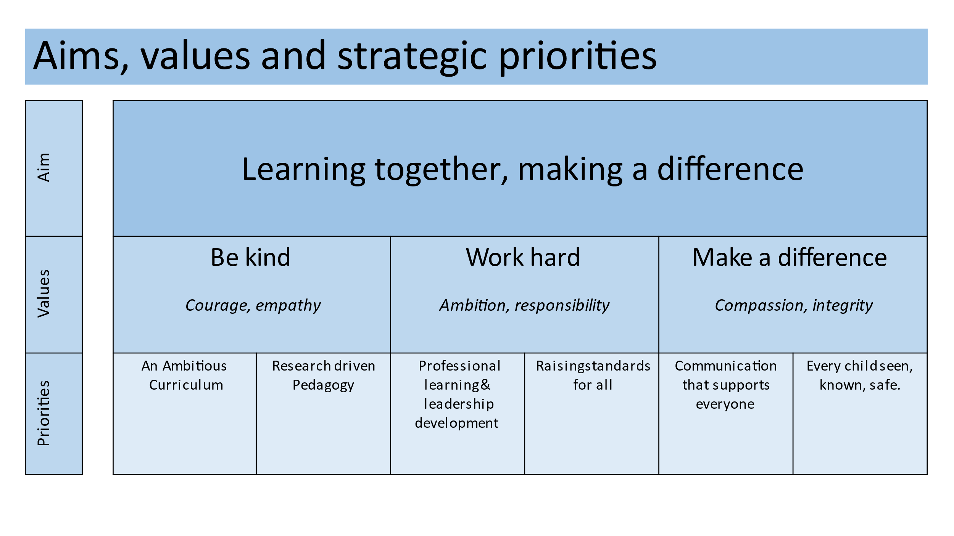
Key Achievements at MHSF over 21-22
- The continued development of a federation culture and ethos built on high expectations for all pupils and calm, consistent adult behaviour
- The continued development of a thought-provoking, rich and ambitious curriculum that is designed to build on each child’s knowledge year on year so that children can make links between their learning
- Improved consistency in teaching and learning across both schools
- A peer-coaching model throughout the schools which has seen improved support for teachers and improved quality of teaching
- Read, Write, Inc. being used in the Juniors as well as Infants
- An improved EYFS curriculum and delivery
- Continued good communications to parents with half-termly Class Rep meetings with Ms Wynne, a termly parent SEND forum with the two SENDCOs and a vibrant, informative newsletter, wider opportunities for parents to come in and see children’s learning, and better opportunity for parents to give feedback
- A return to the many exciting extra-curricular activities for children such as school performances, sports day, musical and performance opportunities, sports opportunities and visitors
- Improved Pupil Premium offer and reporting to the governing board

Other work Governors have undertaken this year
Governors have been active in supporting with staff recruitment, in improving communication between the schools, governors and parents, in supporting Barnet’s proposal for greener heating for the schools, and with school events, such as the fireworks and summer fair.
At the beginning of the year we recruited a new clerk to the board, in order to support the functioning of the meetings, processes and policies. Governors are also committed to further developing their own skills and have attended a variety of training including; safeguarding and prevent, fire awareness, governor induction, Barnet Council’s Chairs and Vice Chairs Directors’ Briefing and Discussion Forum, Ofsted preparation, financial training, Safer Recruitment, school INSET
Areas for Action within the Governing board in 22-23
- Governors understanding the governance structure clearly - can use induction to make this clearer
- Governors understand the legal, regulatory, and financial requirements and understand the need to have regard to any statutory guidance and government advice, including the Governance Handbook
- Governors to work strategically with school leaders to improve the condition of each site and undertake plans to reduce Carbon impact.
- Governors to feel they know the Infants School as well as the Juniors School and support the Infant school to achieve a Good rating at their next Ofsted Section 5 Inspection
- Ensuring governors feel connected to each other and fully understand their roles – through training, meetings, visits
- Governors’ actions and behaviours to follow the Governor Code of Conduct and 7 Principles of Public Life
- For individuals to undertake more training throughout the year and disseminate their knowledge to others
- Review of governor recruitment process
- Review of board make-up
- Review of SIP monitoring pairings and focus

