Moss Hall Schools Federation
MHSF Governor Profiles

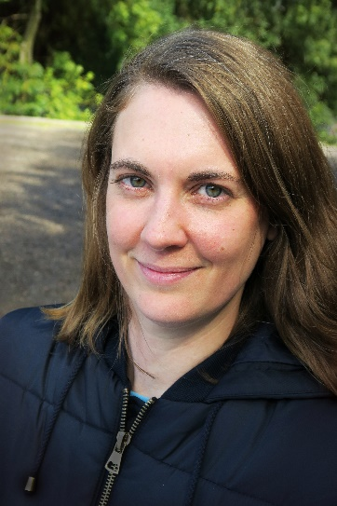
Lis Maimaris - Parent Governor:
Lis is a Parent Governor and is currently Acting Chair of Governors. She has two children at Moss Hall. Lis comes to the role of governor with a background in education and is a trained secondary English teacher. For ten years she worked in management roles for Islington Council. Currently Lis works as a teaching assistant in a primary school. Lis is interested in all aspects of education and she is always keen to learn more!

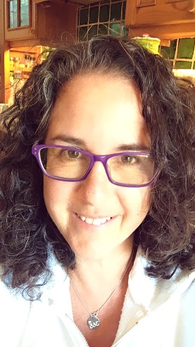
Holly Kal-Weiss - LA Governor:
Holly is a Local Authority Governor, appointed in December 2018. She lives in High Barnet and is a retired dyslexia specialist teacher. She started her career as a children and families social worker and moved on to train in informal education, early years, primary and then special education. She is a local activist involved in fighting homelessness in Barnet. Holly’s areas of responsibility at Moss Hall are the Relationship and Sex Education curriculum and the Early Years Foundation Stage.

Patrick Richmond - Co-opted Governor:
Patrick is a co-opted governor and is the link governor for Compliance and Safeguarding. He was previously a senior leader at a large primary school leading on the EYFS and attendance. He currently works in the independent sector and is also a Trustee for BEAT (Barnet Educational Arts Trust).

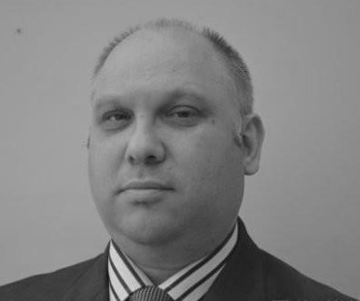
David Dunn - Co-opted Governor:
David is a co-opted school governor and has been on the Board since December 2020. He is a Chartered Management Accountant and has lived in Barnet for nearly 20 years. Although this is his first role as a school governor, he is passionate about giving back to his community. He is looking forward to being able to contribute to the growth and success of Moss Hall.

Mo Choonara - Co-opted Governor:
Mo is a Co-opted Governor, appointed in 2021. Born and raised in North London, he now works as a policy adviser at the Department for Education on issues including racism in schools, political impartiality and Relationships & Sex education. He is invested in supporting the schools thrive and improve, and learning more about the challenges and opportunities staff, pupils, parents and carers see.

Joel Phillips - Co-opted Governor:
Joel is a co-opted governor on the Federation board and was previously a parent governor at the Junior school, elected in 2016. He is currently acting as Vice-Chair. Joel is a quantitative researcher at a city trading firm and previously worked as a maths lecturer. Joel helped lead the schools into federation and is pleased to be helping them realise the potential that that created.

Adrian Sieff - Parent Governor:
Adrian is a Parent Governor and has worked on policy, strategy and law in the Department of Health, Audit Commission and Social Exclusion Unit; and person-centred care and quality improvement at the Health Foundation. His early career was working for a student organisation and then basic accountancy training. He has been a volunteer and Trustee in charities working for homeless people, the environment and international development. His current employer is his two young sons, both of whom are at Moss Hall. They occasionally let him out to do other things.

Andrea Muhammad - Co-opted Governor:
Andrea is the Chair of the Premises, Finance and Resources Committee. She is an accountant and has worked for over 20 years in the financial services sector in both risk management and finance. She currently works for the Prudential Regulation Authority which is part of the Bank of England. She believes that all children are entitled to a high-quality education and is proud to support the Moss Hall Schools Federation.

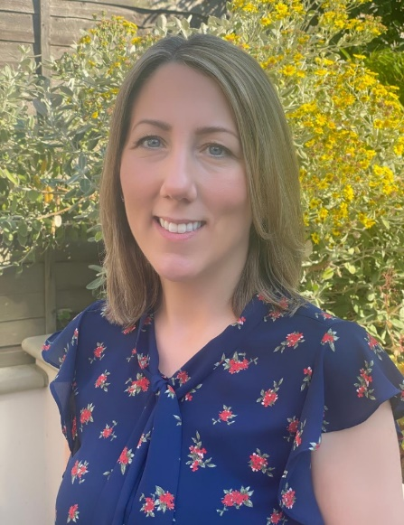
Chloe Khan - Co-opted Governor:

Chloe is currently the link governor for SEND, PPG and the SIP priority area ‘Every Child Seen, Known, Safe’. Chloe is a Qualified Advisory Teacher of the Deaf working within the Education Inclusion Team for two local authorities and has over twenty years’ experience supporting children aged 0-19 and their families. Chloe works closely with a range of professionals from health, social care, and education, providing a collaborative approach to achieving the best possible outcomes for all children and young people. Chloe is passionate about high quality SEND provision and particularly about embedding the principle of empathy as the foundation for meaningful relationships and strong parent partnerships in education.

Dr Victoria L. Whitford OBE - Co-opted Governor:
Victoria OBE graduated from Balliol College Oxford with first class honours in Physics and Philosophy. She served in HM Diplomatic Service for 17 years, where she was posted to Brussels, Kosovo, Iraq, Afghanistan, the United States and India. She has served in a variety of senior leadership roles, including as Deputy Head of the Commercial and Economic Diplomacy Department at the Foreign and Commonwealth Office and as International Director at the Intellectual Property Office. In 2015 she was elected as a Parent Governor at Moss Hall Infant School and also changed career, retraining as a medical doctor. She is currently an Academic Foundation Doctor at the Royal London Hospital in Whitechapel. She helped lead the transition of Moss Hall Infant and Junior Schools to the Moss Hall Schools Federation. When not working, she enjoys horse-riding, running, wild swimming, gardening and reading.

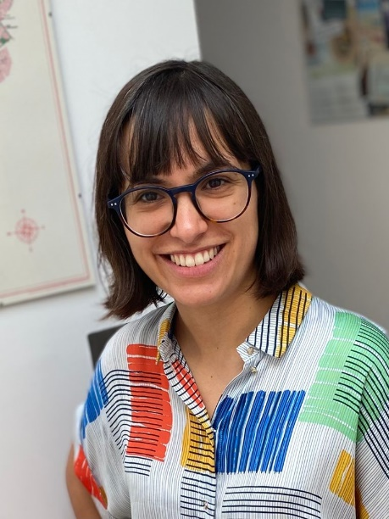
Andrea Pieri Gonzalez – Co-opted Governor
Andrea is a co-opted governor, appointed in 2021 – the same year she embarked on her journey as a mum. She lives in Whetstone and grew up in Finchley. She has worked in arts education for over 10 years and is currently working for a theatre company where she designs and delivers theatre-based projects for schools, young people and other members of the community. She’s passionate about the role the arts can play in supporting children to understand themselves and the world around them. She’s excited to support Moss Hall in ensuring every pupil thrives, can hold a point of view and make a positive contribution to society.

