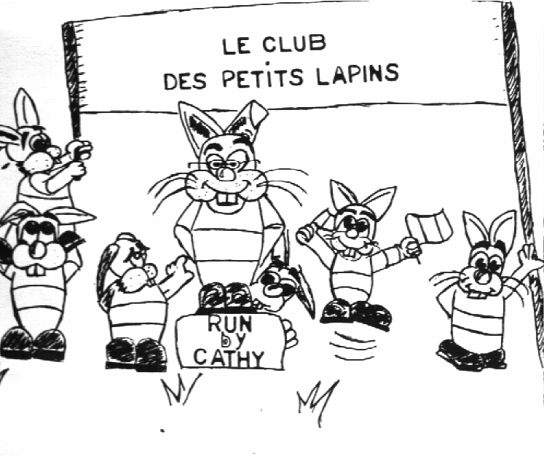

Le Club des Petits Lapins

www.leclubdespetitslapins-barnet.co.uk
29 Kingsmead, New Barnet Herts EN5 5AX
Mobile 07415-209-165
Email les_petitslapins@yahoo.com
NEW PUPILS ONLY
MOSS HALL
From YEAR 1
Dear parents,

This letter is to inform you that “LE CLUB DES PETITS LAPINS” runs French classes at Moss Hall. It is the opportunity for your children to learn a foreign language with fun.. Our methods include games, songs, flash cards, stories and worksheets which in themselves do not look like work at all. Our teaching programme is carefully chosen to suit the age and abilities of the children. Each group we teach for an hour has a maximum of 9 children.

The cost for one-hour session is £14 per child. Full term payment is to be made no later than 17th July. Our membership fee (a one-off payment) is £15.00
Classes are held Thursdays from 3.15 p.m to 16.15 p.m . Groups will start on the 11th September 2025 , last session 18th December 2025

As the number of each class is limited, I would advise you to book early and send your reply slip by mail or on whatsapp together with the full term fee of £ 211 (14 sessions, + membership)
Please note that the fees will not be refundable.

If at any time you wish to speak to me, please do not hesitate to contact me at the above number. PLEASE DO NOT LEAVE ANY FORMS AT SCHOOL OFFICE, ALL FORMS MUST BE SENT BACK TO US .
The teachers and I look forward to see the children in September
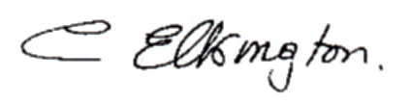Yours faithfully,


Mrs C. Elkington

Please complete the form at the back and return by mail or Whatapp

MOSS HALL – ENROLMENT FORM
(New pupils Only)
FROM Year 1
I would like my child to join French classes at Moss Hall and Transfer to Les Petits Lapins Acc: 04315303 Sort code: 09-01-28 (reference: (Name of child / school) for £211

Surname
……………………………………………………………………………...

First name

……………………………………………………......................Boy/Girl

Date of birth Age …………………………………………... ………………………......

Email address

……………………………………………………………………………...

Address ……………………………………………………………………………...

……………………………………………………………………………...

Name of class in September…………………………………………

Tel N° Home.....................................Work........................................

Mobile...............................................................................................

Name of Parent/Guardian .............................................................

